DLCV HW0

學號：b08502141 姓名：石旻翰 系級：電機三

Reference: https://github.com/thtang/DLCV2018SPRING/tree/master/hw1

Collaborator: B07502071陳志臻

1. Plot mean face and eigenfaces.

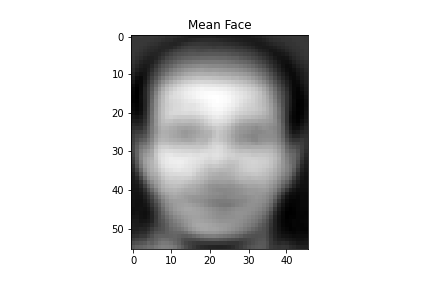<mean face>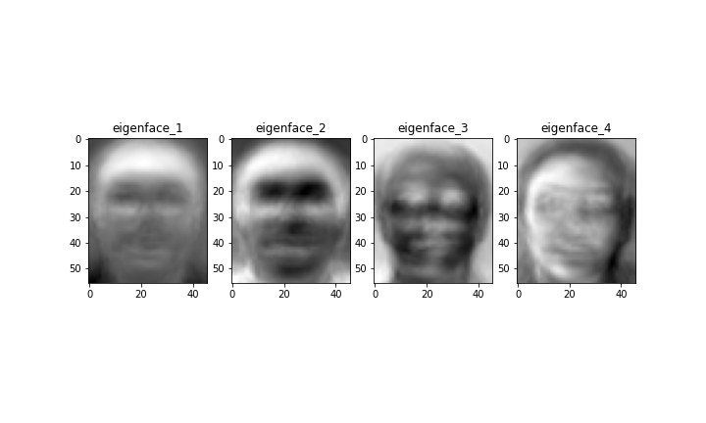 <eigenface1-4>

1. Plot the five reconstructed images.

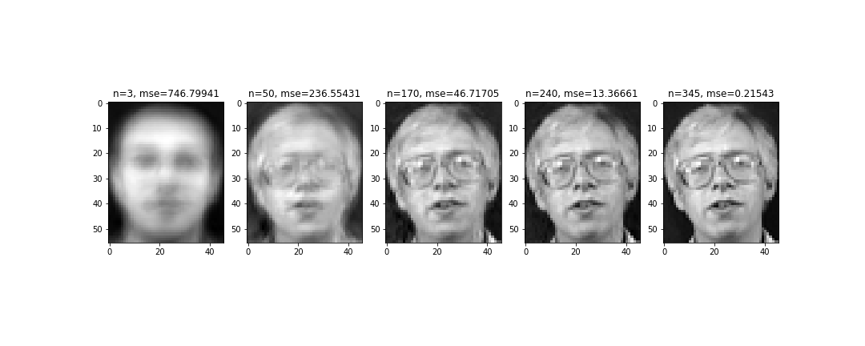

<reconstructed images>

1. Record the corresponding MSE values in your report.

|  |  |  |  |  |  |
| --- | --- | --- | --- | --- | --- |
| n | 3 | 50 | 170 | 240 | 345 |
| MSE | 746.79941 | 236.55431 | 46.71705 | 13.36661 | 0.21543 |

1. Show the cross-validation results and explain your choice for (k, n).

|  |  |  |  |
| --- | --- | --- | --- |
| n\k | 1 | 3 | 5 |
| 3 | 0.65 | 0.611 | 0.561 |
| 50 | 0.961 | 0.9 | 0.847 |
| 70 | 0.956 | 0.889 | 0.822 |

**Ans: From the above output with 3-fold cross validation, we can find out the best parameters should be k=1 and n=50.**

1. The recognition rate of the testing set, when k = 1, n=50.

**Ans: 0.925(92.5%)**